Difficulty Rating: 3.5
From: Billy Bob <billy.bob@evisions-portal.com>
To: John Doe <john.doe@evisions.com>
Reply-To: Evisions SEA Accounts <sea-accounts@evisions.com>
Delivered-To: john.doe@evisions.com
Content-Type: text/plain; or Content-Type: multipart/alternative;
Subject: Action Required: SEA License Activation Expiring Soon
------------------------------------------------------------------------------------------------------------------
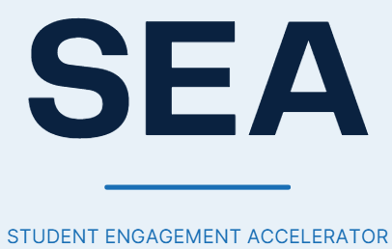
Dear John,
Your Social Engagement Accelerator (SEA) license activation is nearing its deadline. To avoid a lapse in service for The University of Alabama in Huntsville (UAH), please review and confirm your licensing details before the window closes
License Summary
Item | Detail
Product | Social Engagement Accelerator
License Type | Annual, standard tier
Term | 12 months (multi-year discount applied)
Support Included | Standard support, included at no additional cost
Activation Deadline | 48 hours from receipt of this email
Next Step
Please confirm your license and sign the attached agreement using the secure portal below
https://sea-accounts.evisions.com.account-verify.net/activate
Attachment: SEA_Licensing_Agreement_UAH.pdf
If you have any questions, reply to this email or reach out to sea-accounts@evisions.com
Thank you for your prompt attention
Best regards
Billy Bob
Product Manager, Social Engagement Accelerator

Evisions

